**RESULT VISULIAZATION**

1. UNSUPERVISED LEARNING VISUALIZATION.

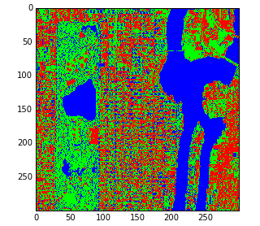

1. SUPERVISED LEARINING VISUALIZATION.

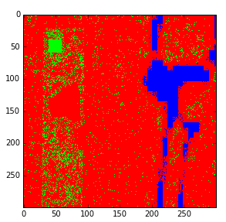

NOTE: 1. RED—BUILDINGS

2. GREEN—EMPTY LAND

3. BLUE--WATER